**Lesson 04 Demo 04**

**Creating a Grafana Dashboard Using PromQL Queries to Visualize Specific Application Metrics**

**Objective:** To demonstrate the process of creating a Grafana dashboard using PromQL queries for visualizing specific application metrics

**Tools required:** Linux operating system

**Prerequisites:** Refer to Demo 01 of Lesson 04 for Grafana installation and Demo 02 of Lesson 04 for configuring Prometheus as a data source

Steps to be followed:

1. Create a new dashboard in Grafana to add visualizations
2. Use PromQL queries to visualize the metrics collected

**Step 1: Create a new dashboard in Grafana to add visualizations**

1. Log in to the Grafana server from the browser using the URL **http://localhost:3000**

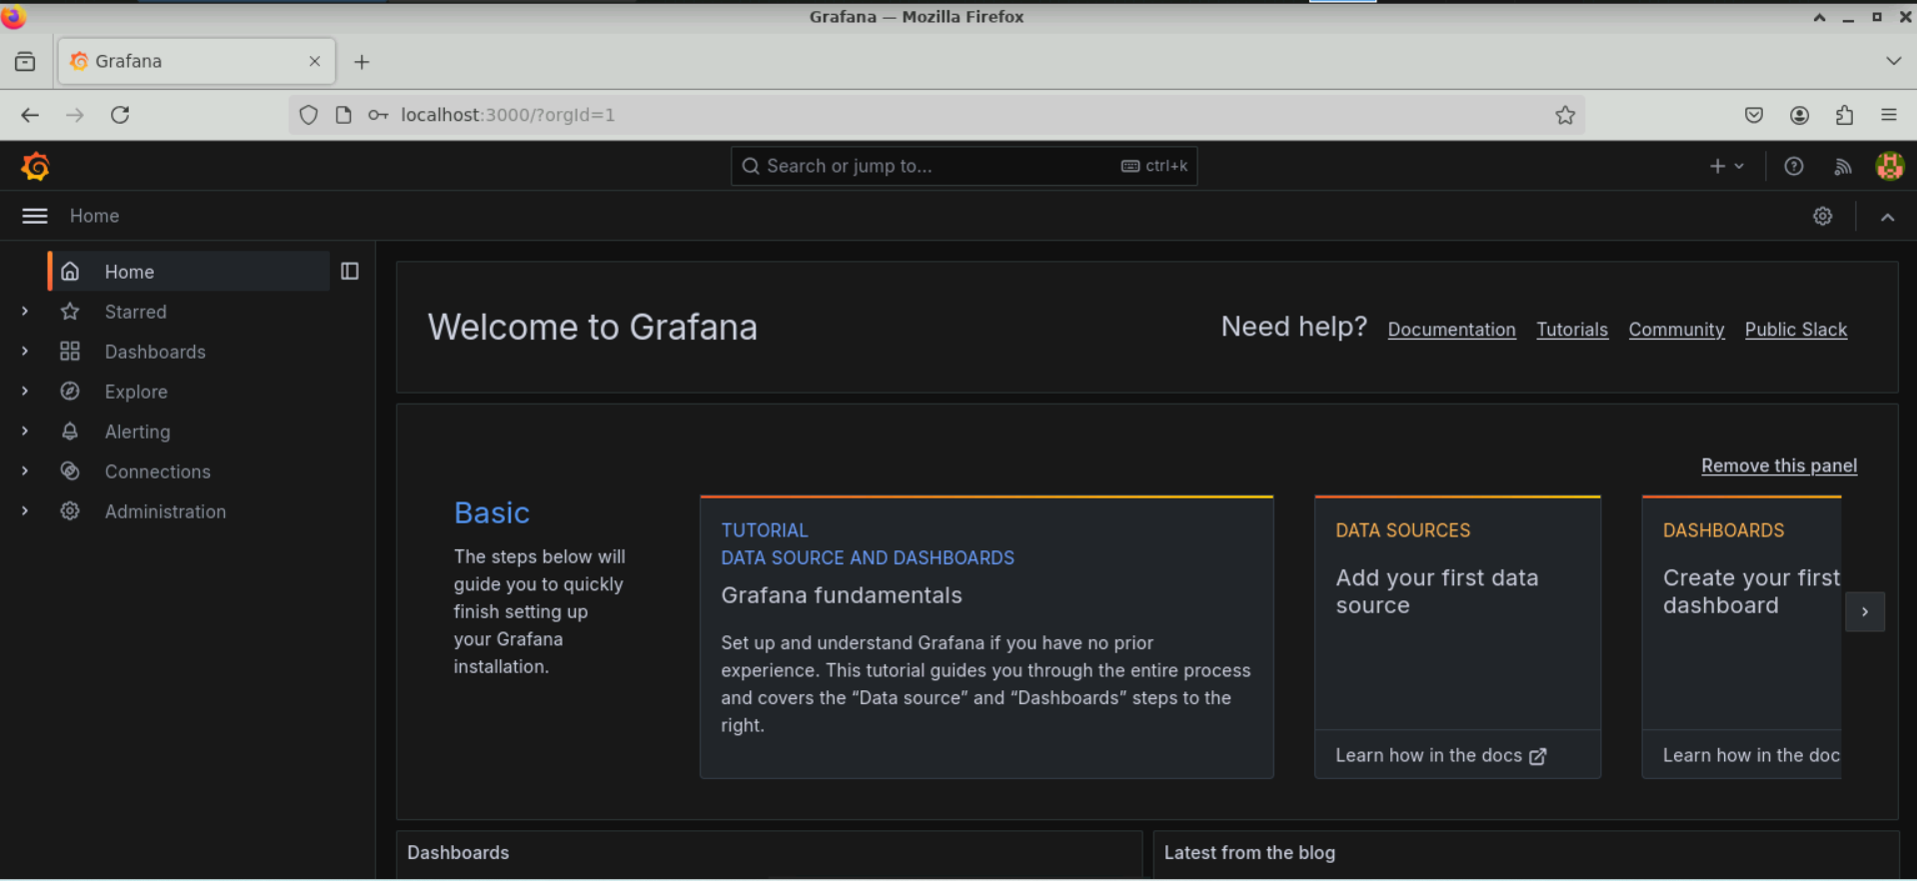

**Note:** Ensure that Prometheus and Node Exporter are running before starting the Grafana server

1. Choose **Dashboards** from the left-side menu and click **+ Add visualization**

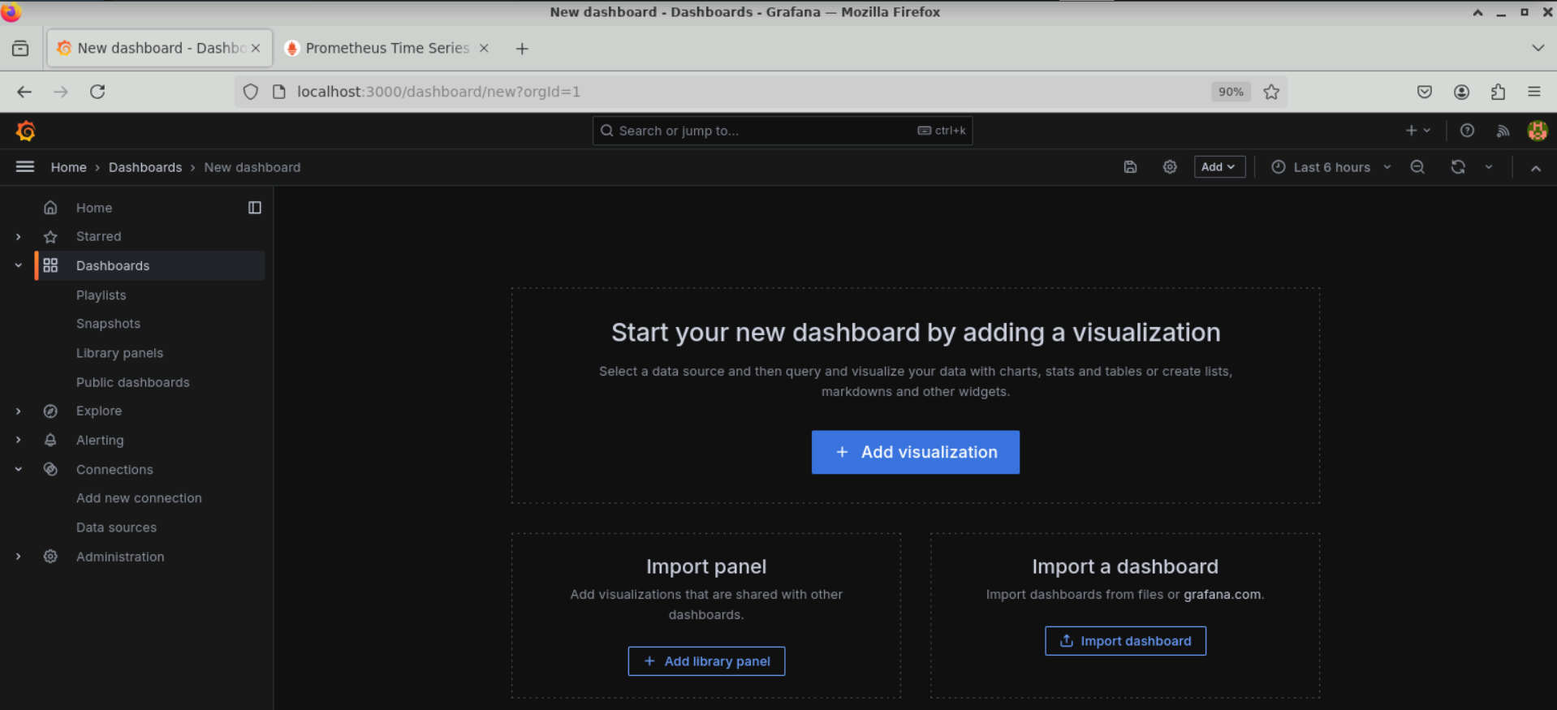

1. Click on **New** and select **New dashboard** to add a visualization

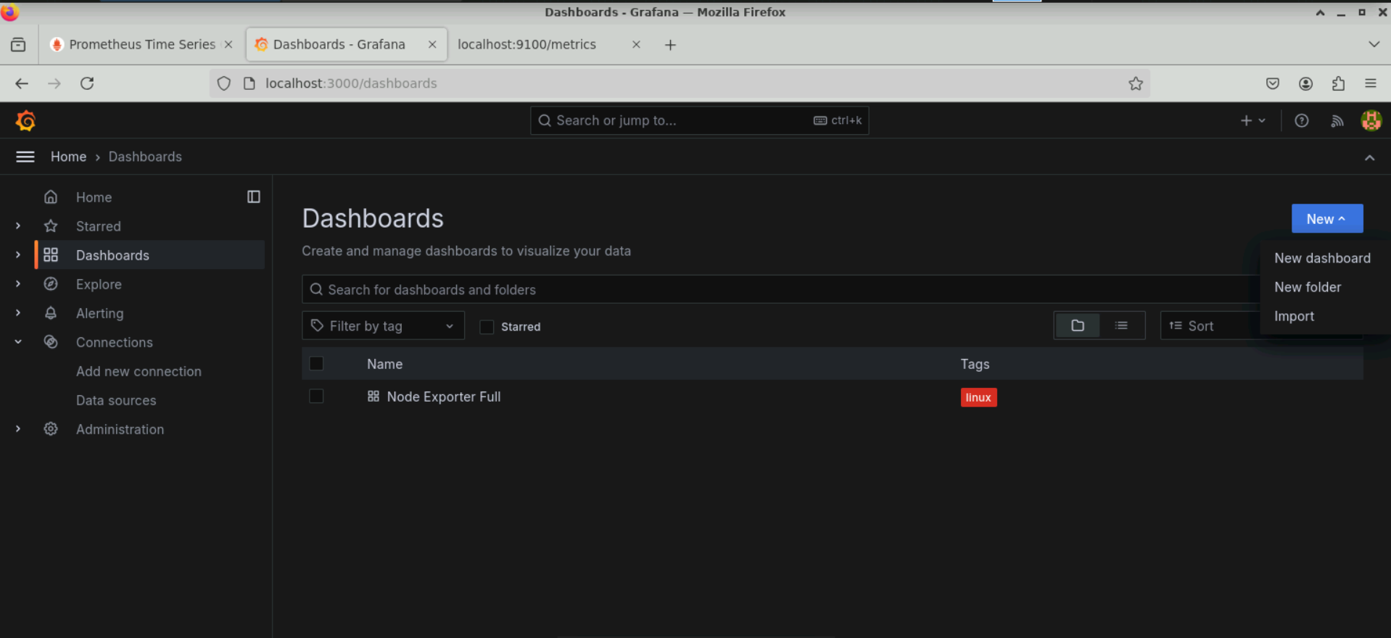

1. Select **prometheus** as the data source

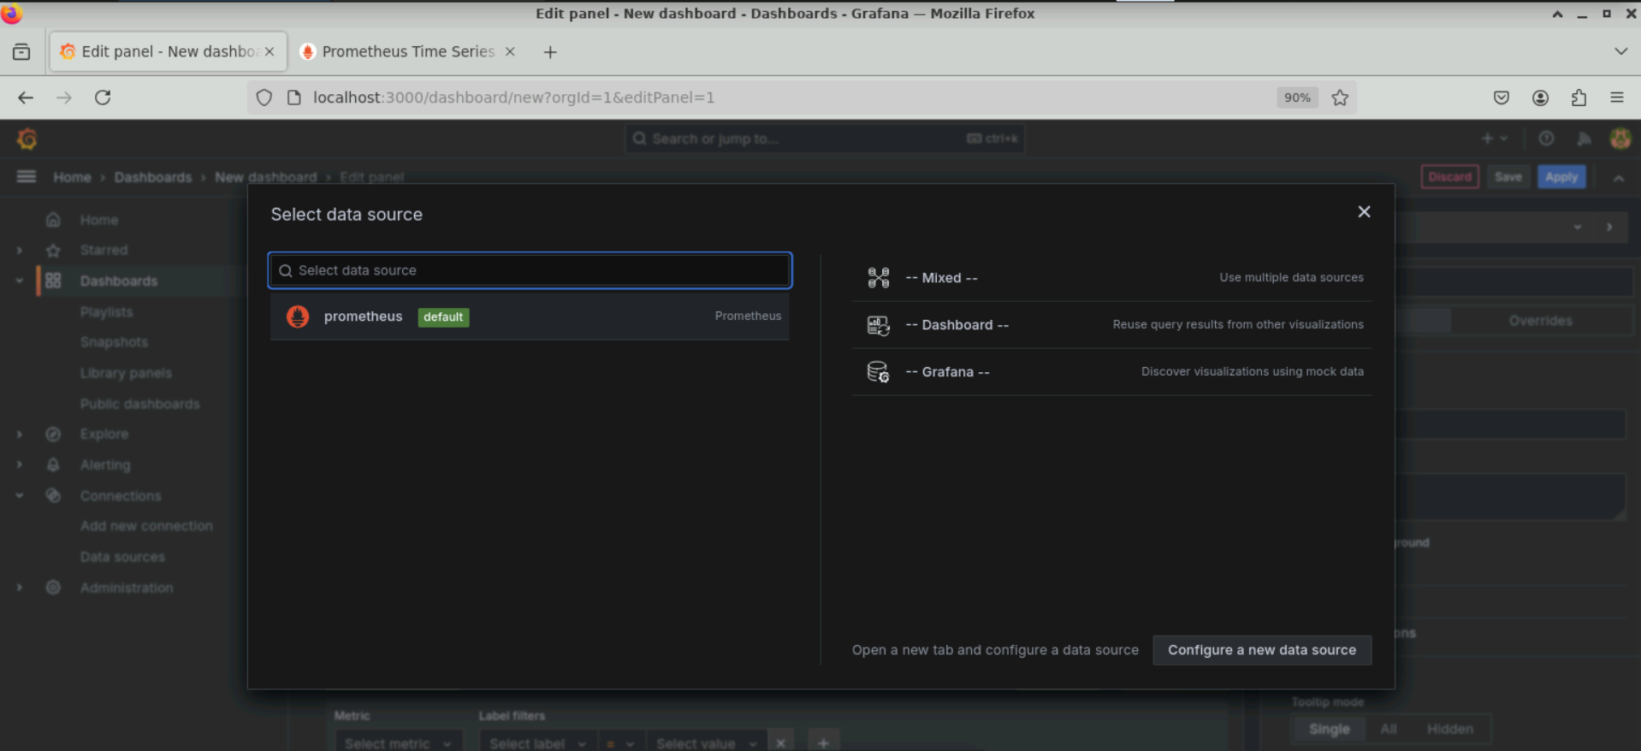

**Note:** Ensure that Prometheus is already configured as a data source

The dashboard will appear as shown below:

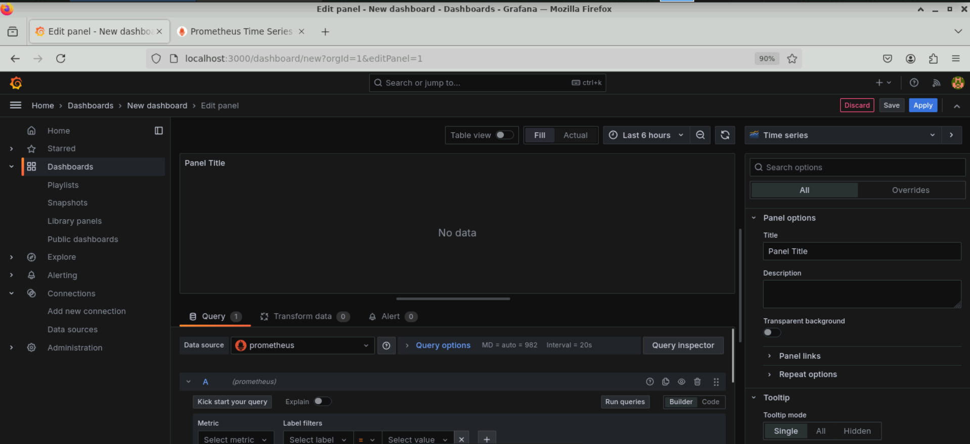

1. Select **Time Series** as the panel type and change the **Title** of the panel to **CPU Usage** under **Panel options**

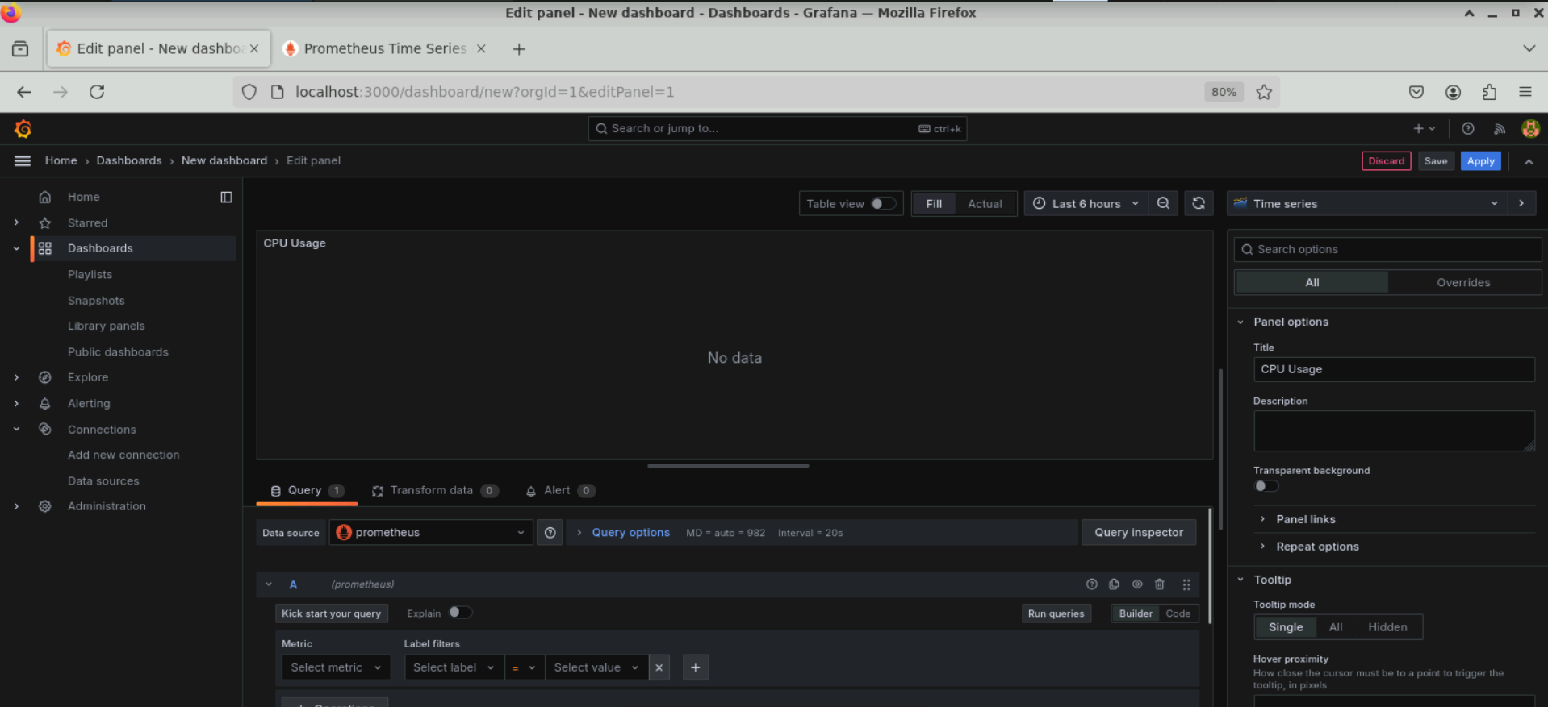

**Step 2: Use PromQL queries to visualize the metrics collected**

1. Under **Query**, click on the **Code** button to display the expression bar for entering queries

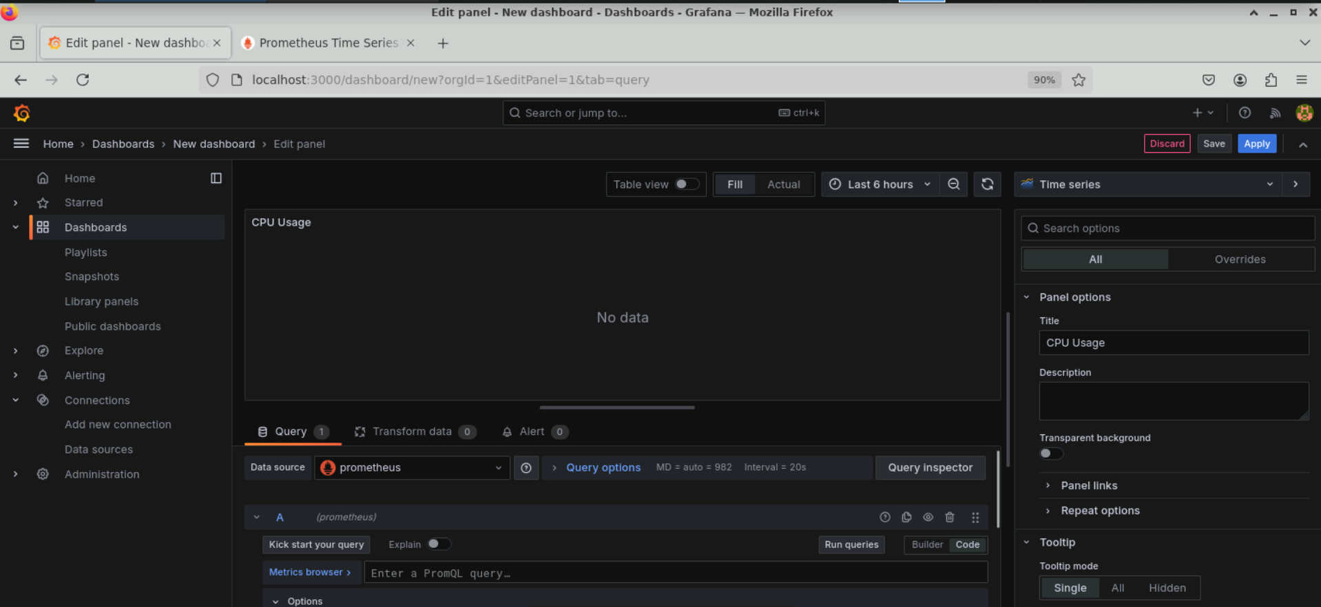

1. Enter the following query and click **Run queries** to execute it:

**100 - (avg by(instance) (rate(node_cpu_seconds_total{mode="idle"}[5m])) * 100)**

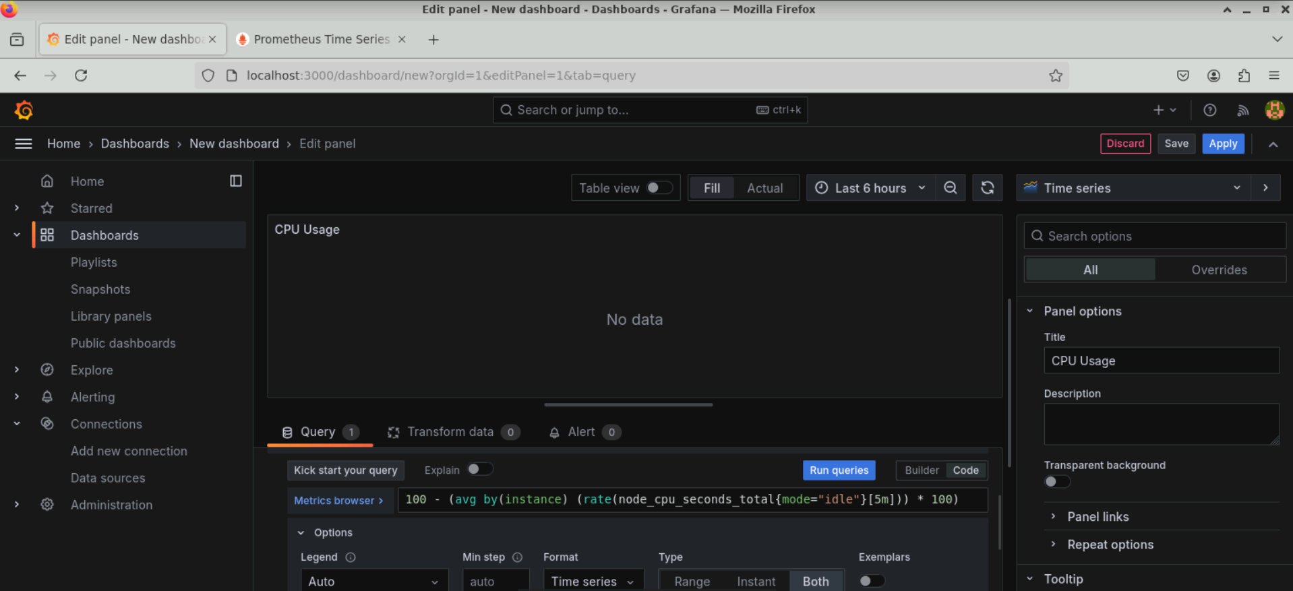

1. Click **Apply** to save this panel to the dashboard

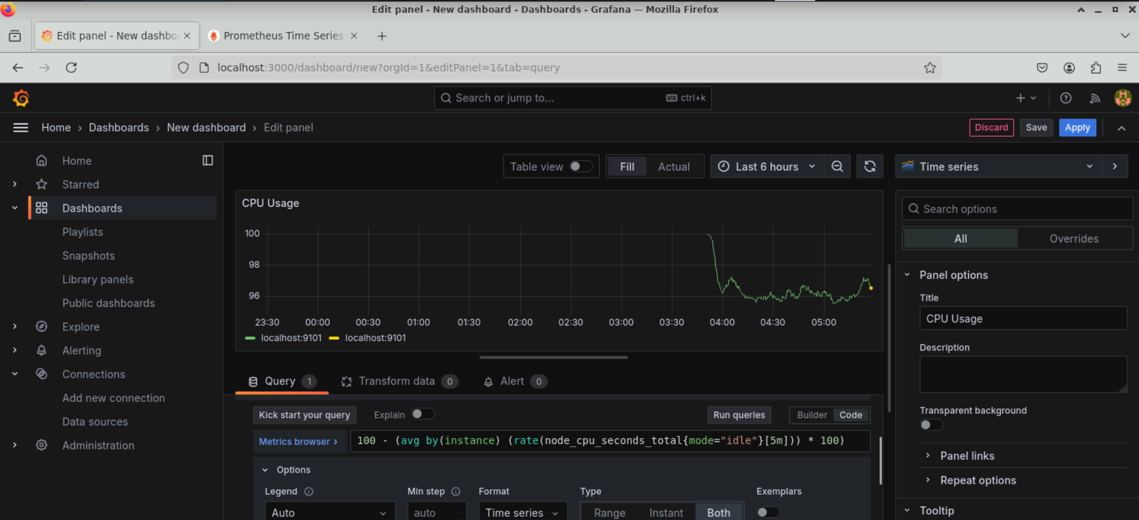

The **CPU Usage** panel will appear on the dashboard as shown below:

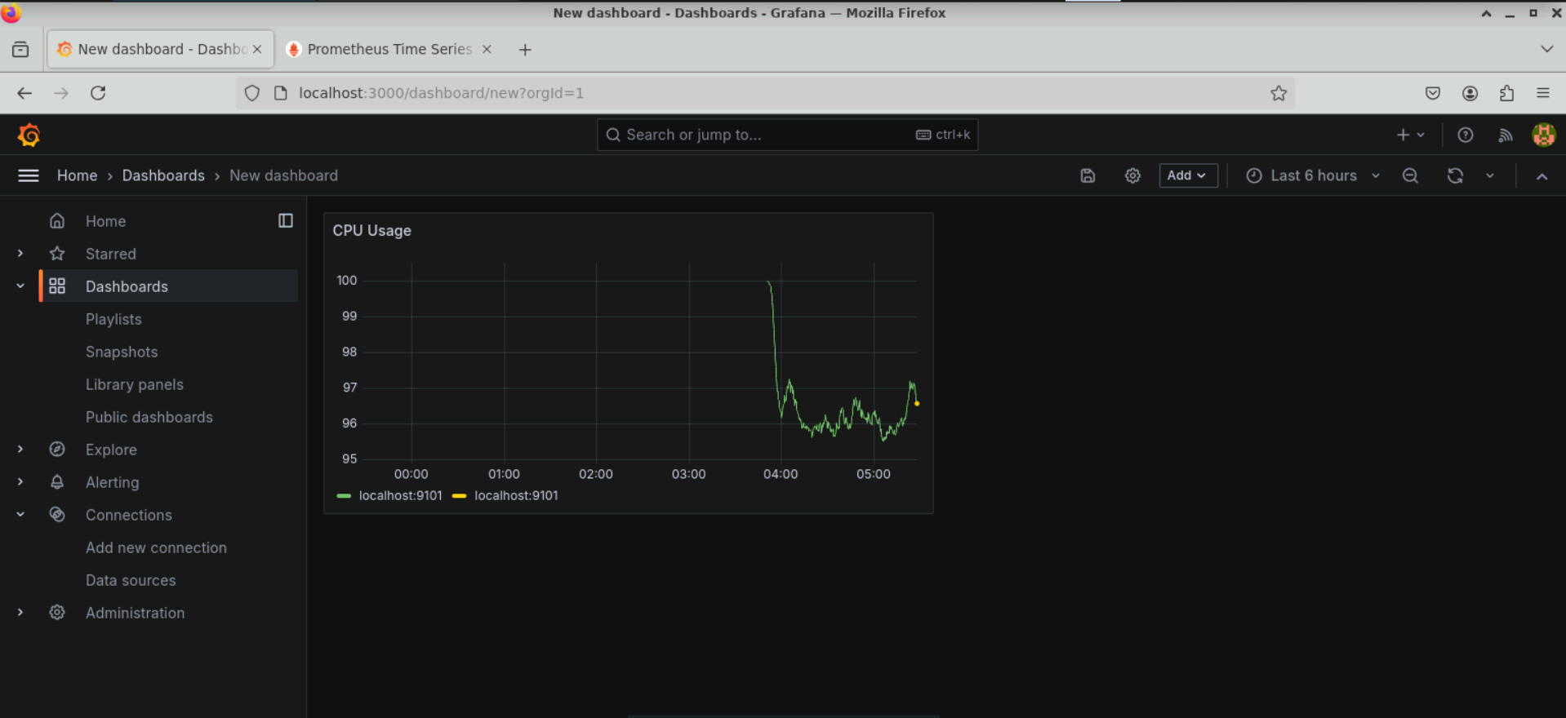

1. Click **Add** and then select **Visualization** to execute the query and add a new panel to the dashboard

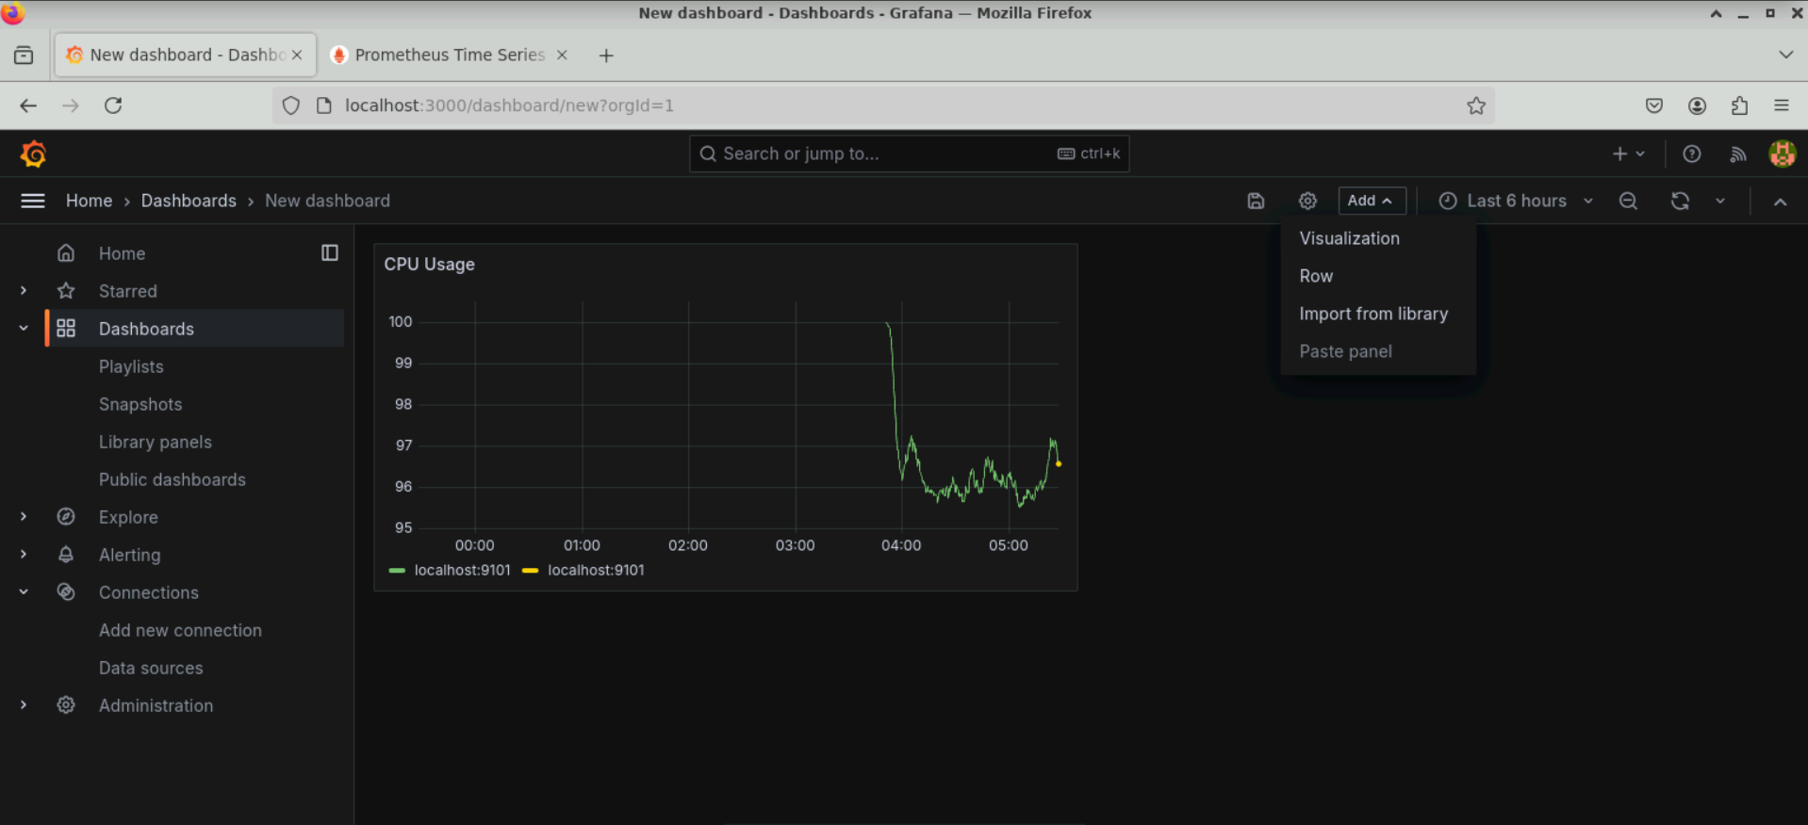

1. Execute the following query, observe the graph, and then save this panel with the name **Memory Usage** by clicking on the **Apply** button:

**node_memory_MemTotal_bytes - node_memory_MemFree_bytes - node_memory_Buffers_bytes - node_memory_Cached_bytes**

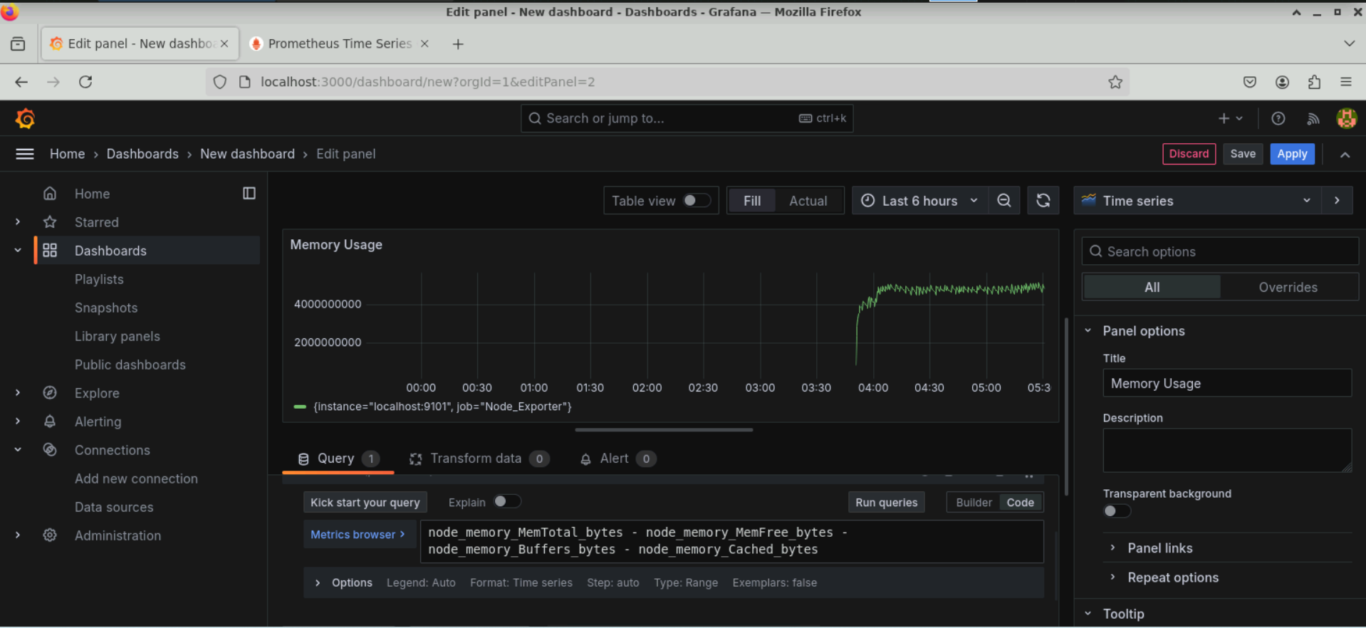

The dashboard now consists of two panels:

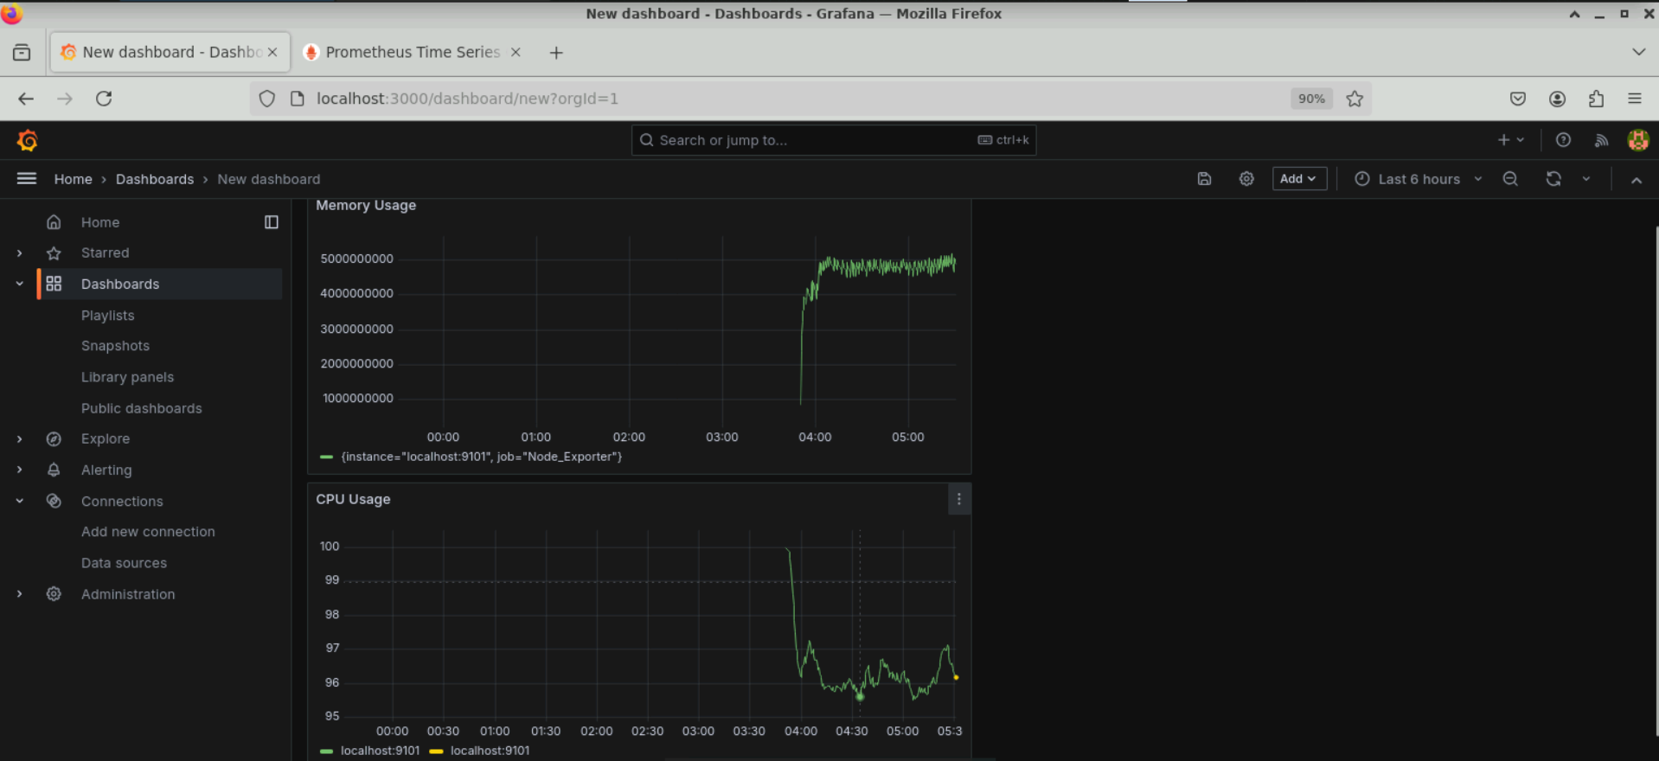

1. Add a panel, execute the following query, and save it as **Visualize Disk Usage**:

**( (node_filesystem_size_bytes{fstype="ext4"} - node_filesystem_free_bytes{fstype="ext4"}) / node_filesystem_size_bytes{fstype="ext4"} ) * 100**

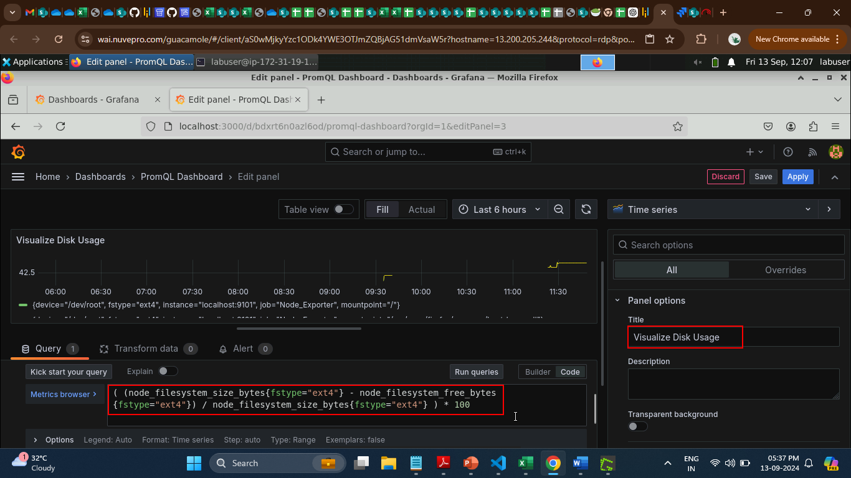

1. Add one more panel, execute the following query, and save it as **Visualize Network Traffic**:

**rate(node_network_receive_bytes_total[5m])**

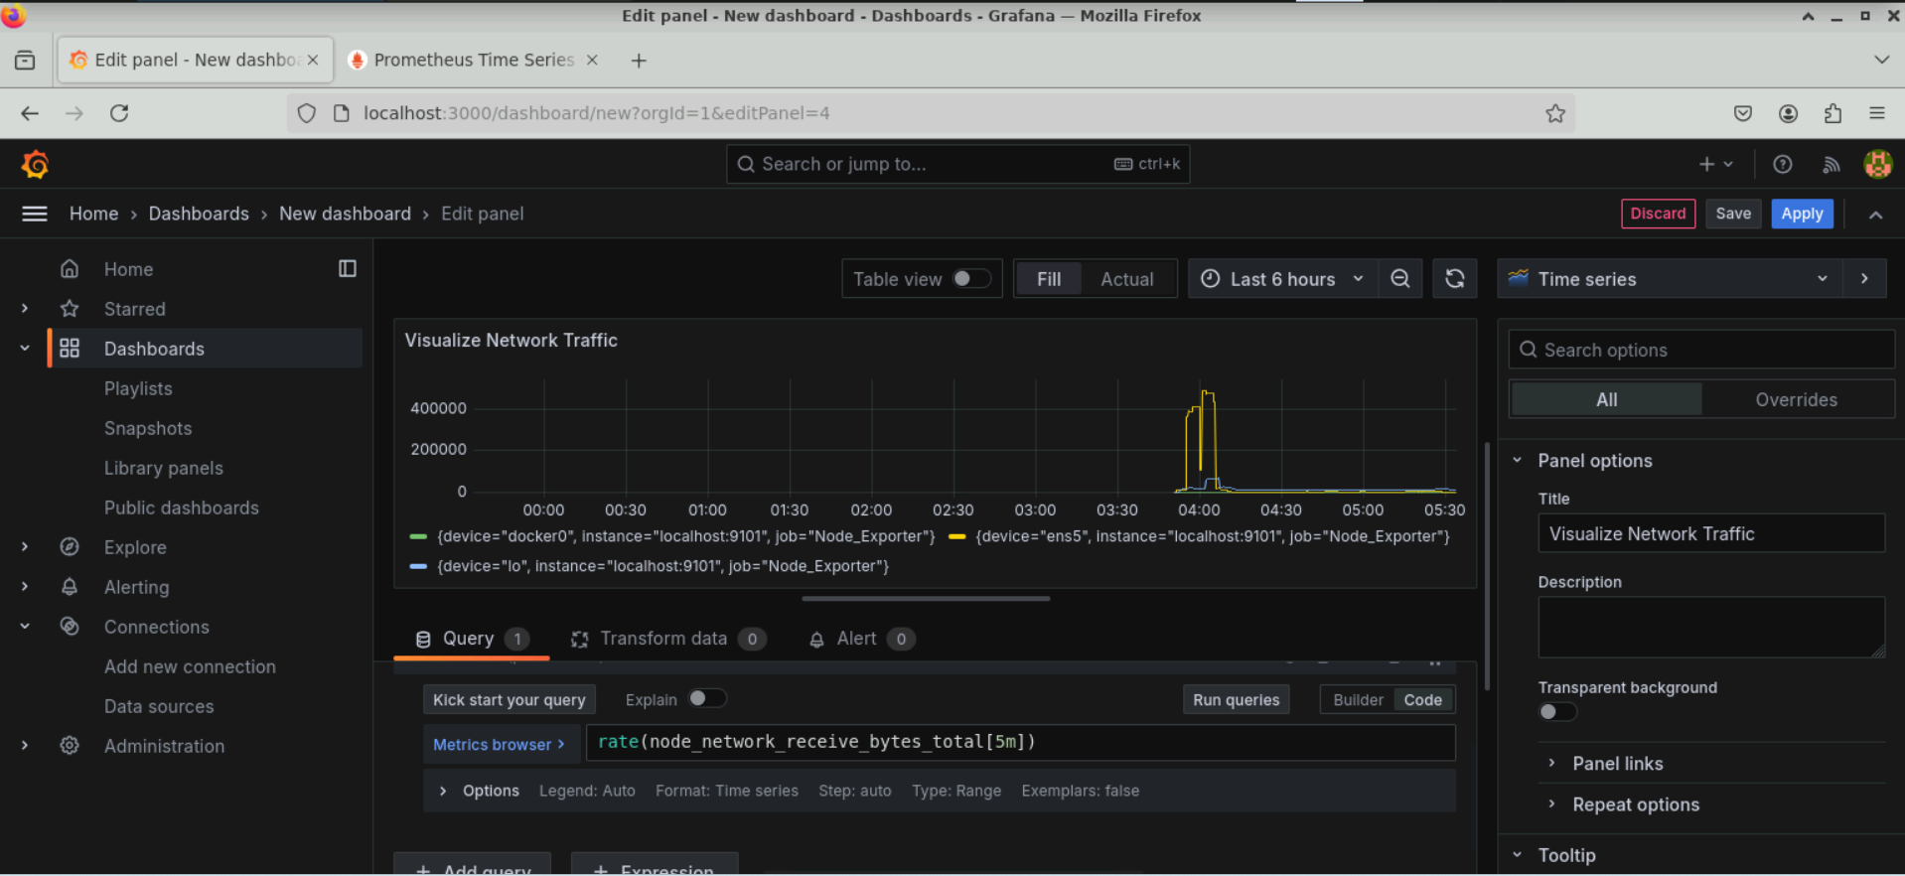

The dashboard now consists of four panels as shown below:

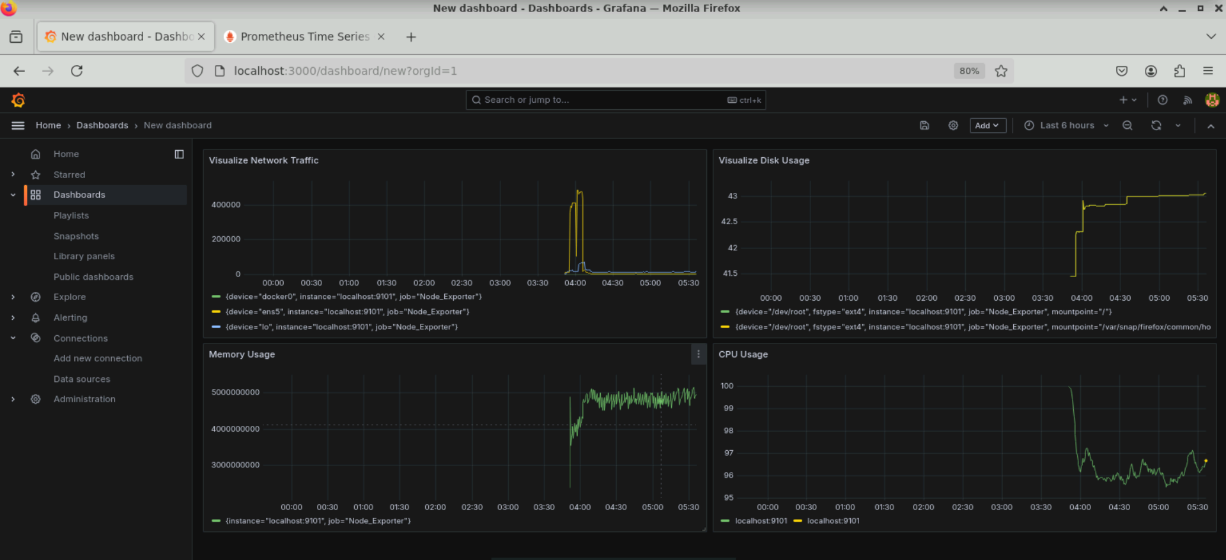

1. Save the dashboard by clicking on the **Save dashboard** icon

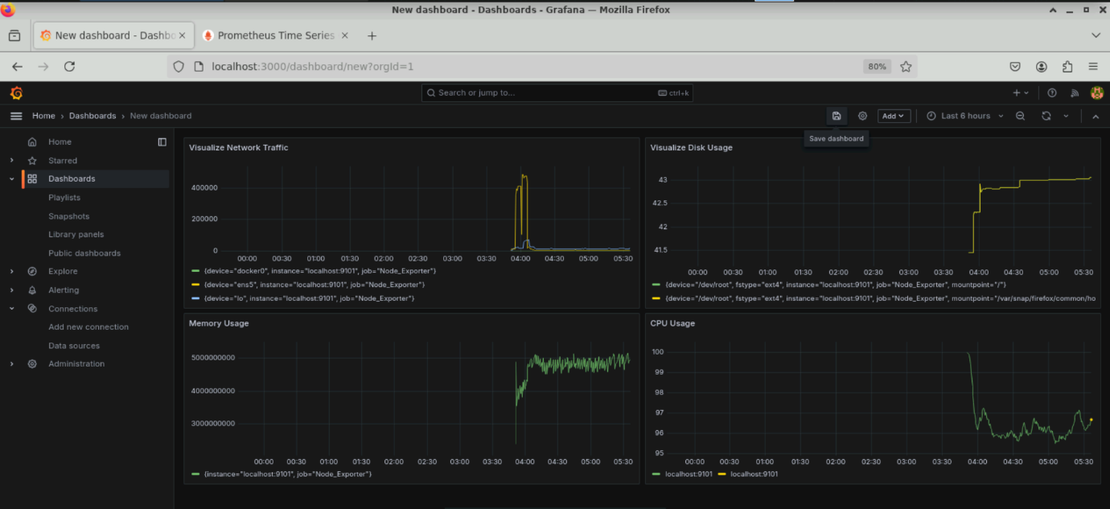

1. Enter the **Title** as **PromQL Dashboard** and the **Description** as **This is my** **PromQL Dashboard**, then click on the **Save** button

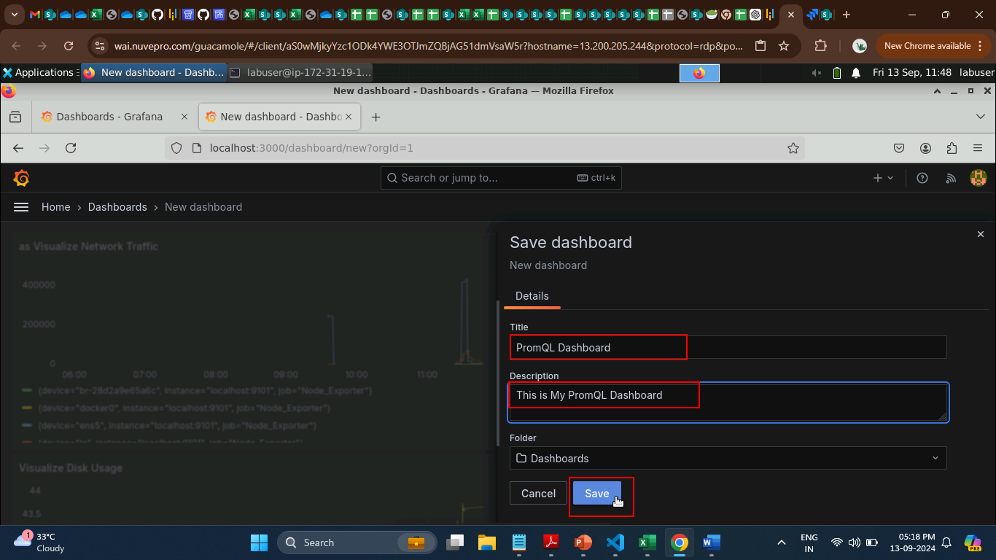

The saved dashboard will appear as shown below:

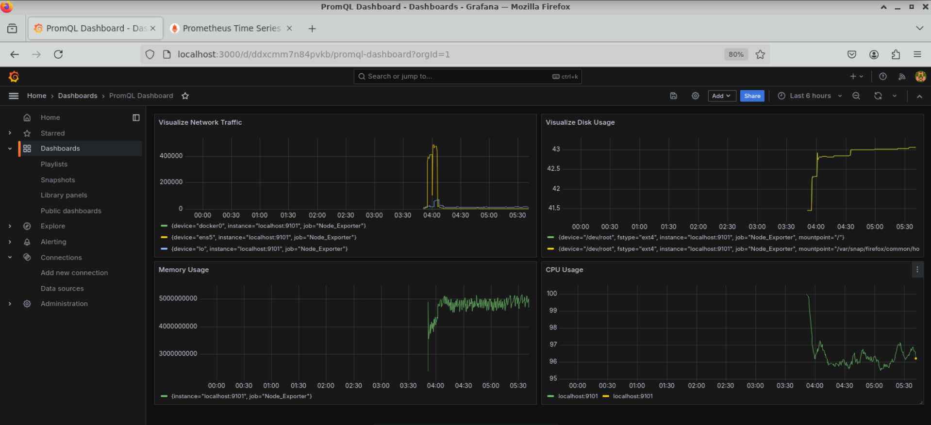

By following these steps, you have successfully created a dashboard with multiple panels using PromQL queries for visualizing key system metrics such as CPU usage, memory usage, disk usage, and network traffic.